Group 8 Team Proposal

Members:

Andres Socorro

Gina Canales

Javier Portocarrero

Jocelyn Flores

**State of Reopening**

**Description:** The goal of this project is to analyze and visualize the effects of the global pandemic from an economic point of view to try to understand its impact, which goes beyond the devastating effects on our health and healthcare that we are all familiar with.

In so, we will analyze how the world and specifically the US has dealt with the pandemic since the beginning of this year by looking at different indicators that give us an idea of what is really going on. Some of the data we want to look at is TSA throughput numbers in 2020 vs 2019 to see how much air travel has decreased this year and how its doing now 8 months after the world stopped in March. Opentable data to look at dining activity, EIA gasoline demand data as well as electricity usage per sector (residential vs commercial) and unemployment data to understand the pandemic’s economic impact.

Data:

TSA Throughput Data: [**https://www.tsa.gov/coronavirus/passenger-throughput?page=0**](https://www.tsa.gov/coronavirus/passenger-throughput?page=0)/ Europe: https://www.eurocontrol.int/covid19

Opentable reservation numbers: [**https://www.opentable.com/state-of-industry**](https://www.opentable.com/state-of-industry)

EIA API for gasoline demand info and electricity usage

Visualizations/design ideas:

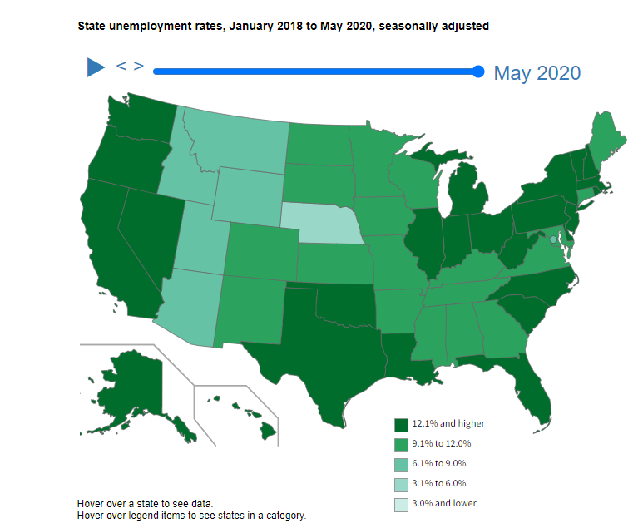

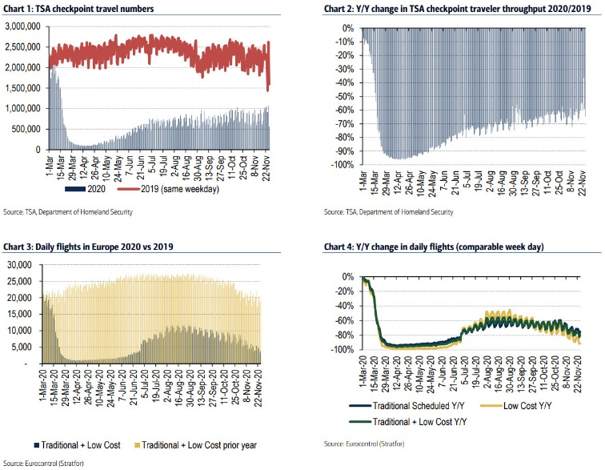

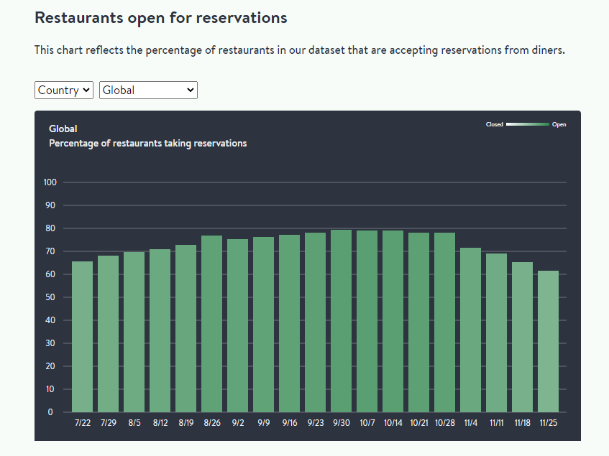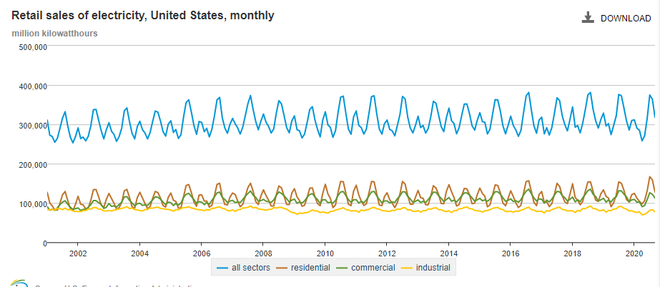

Github link: <https://github.com/gcanales85/Rice-U-Project-2>